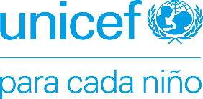

Zaragoza, 07 July 2020
Open Government Partnership
1110 Vermont Avenue NW, Suite 500
Washington, DC 20005

Re: application of the Government of Aragon to become a member of Open Government Partnership
To Whom It May Concern:
UNICEF is the United Nations agency responsible for defending and protecting children around the world. In organisational terms, in addition to its headquarters, it has offices in over 194 countries and territories. In low- and middle-income countries, UNICEF conducts its work by means of the Country Offices with which it fulfils its mission using country plans agreed upon with governments as well as by implementing programmes in different areas. It additionally supports the governments so that policies and budgets are drafted that put children at the centre. In high-income countries, as is the case of Spain, UNICEF has national committees that support its mission. The Spanish Committee for UNICEF is a not-for-profit foundation that has its own legal personality as well as various autonomous committees responsible for contributing to fundraising for UNICEF and, particularly in this case, for promoting and defending the rights of children in Spain.
In Aragon, UNICEF runs several programmes in collaboration with the autonomous regional government:
- Rights Education Programme (In Spanish) – Child-friendly schools and reference centres committed to the promotion and recognition of children’s rights and the exercising of solidarity-based and responsible global citizenship in education. These centres conduct fundraising activities to support the International Cooperation programmes that UNICEF operates across the world. By means of this network of centres, teachers have access to all of the educational resources of the UNICEF programme, share information with other centres and receive periodic information regarding the work of this organisation. The highest level of commitment is achieved in the form of the Reference Centres, which actively conduct a series of actions throughout the school year and represent the highest degree of engagement of an educational centre in the area of rights education. In Aragon there are currently 67 child-friendly schools and 11 reference centres.
- Child Friendly Cities Initiative – The Government of Aragon supports the creation and maintenance of 30 Child and Youth Councils in local Aragonese entities. These cities take an additional step in their commitment by joining the UNICEF Child Friendly Cities programme. As a result of the health crisis caused by COVID-19 in 2020, both institutions are collaborating in the development of a remote child participation and education programme.
We believe that incorporating the Government of Aragon into OGP constitutes an opportunity to disseminate child protection values even more, spreading the activities performed with UNICEF Aragon to other areas and contributing towards actively including children in Open Government policies.

In Zaragoza, on 7 July 2020

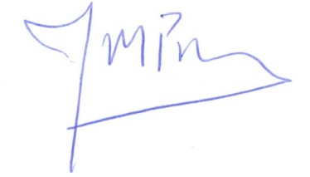

José Manuel Pomar Sasot
President of UNICEF – Committee of Aragon

